FITBUDDY
AI FITNESS PLAN GENERATOR

A Project Report

Submitted in partial fulfillment of the requirements
for the completion of the project

Submitted By
KAVYA S.T 2522K0602
LIBITHA R 2522K0604
MAHIMASRI S 2522K0605
LAKSHANA K 2522K0603

Under the Guidance of
[GUIDE NAME]

DEPARTMENT OF COMPUTER SCIENCE
NAVARASAM ARTS & SCIENCE COLLEGE FOR WOMEN ,ERODE
2026

ABSTRACT

FitBuddy is a web-based AI-powered wellness application designed to help users generate personalized fitness plans based on their basic fitness information and selected goals. The application collects user details such as name, age, weight, fitness goal, and preferred workout intensity through a simple web interface.

The system uses the Google Gemini AI model to generate a structured seven-day fitness and wellness plan according to the information provided by the user. Along with the workout plan, the application provides general nutrition and wellness tips. Users can also submit feedback on their generated plan, allowing the system to produce an updated plan based on their requirements.

The application is developed using Python and the FastAPI framework for backend processing. Jinja2 templates are used to provide the web interface, while SQLite is used to store user information and generated plans. The application also includes an interface for viewing stored users and their plans.

The main objective of FitBuddy is to provide an easy-to-use platform that combines web technology, database management, and generative AI to provide structured and personalized general wellness guidance. The system is intended for general fitness and wellness support and does not provide medical advice.
Keywords
Artificial Intelligence, Gemini AI, FastAPI, Fitness Plan, Wellness, Python, SQLite, Personalized Workout

1. INTRODUCTION
In recent years, technology and Artificial Intelligence have become increasingly useful in supporting personal wellness and fitness activities. Many people find it difficult to create a simple and structured workout routine that matches their individual goals, preferences, and daily requirements. FitBuddy is developed as a web-based AI wellness application to address this requirement by providing personalized general fitness guidance.
FitBuddy allows users to enter basic information such as their name, age, weight, fitness goal, and preferred workout intensity. Based on these inputs, the application uses a Gemini AI model to generate a structured seven-day fitness and wellness plan. The generated result is presented through a simple and user-friendly web interface.
The application also provides general nutrition and wellness tips along with the fitness plan. If a user wants changes to the generated plan, feedback can be submitted through the application. The system processes the feedback and generates an updated plan according to the user's requirement.
The backend of FitBuddy is implemented using Python and FastAPI, while Jinja2 templates are used for rendering the web pages. SQLite is used for storing user information and generated plans. The application also provides a view for accessing stored user and plan information.
The primary purpose of FitBuddy is to demonstrate how generative AI, web development, and database technologies can be integrated into a single application to provide personalized general wellness guidance in an accessible manner. The application is intended for general wellness support and is not a substitute for professional medical advice.

2. PROBLEM STATEMENT
Many individuals want to maintain a healthy and active lifestyle but may find it difficult to create a suitable workout routine based on their personal requirements. General fitness plans available online may not always consider the user's age, weight, fitness goal, and preferred workout intensity.
Another challenge is that users may need to modify their fitness plan when their requirements or preferences change. Without an interactive system, creating and updating a personalized plan can require repeated manual effort.
Therefore, there is a need for a simple web-based application that can collect basic user information, generate a structured fitness and wellness plan, provide general nutrition guidance, and allow users to update the generated plan through feedback.
FitBuddy addresses this requirement by integrating a web interface, database storage, and Gemini AI-based content generation into a single application.

3. OBJECTIVES
The main objectives of the FitBuddy project are:
- To develop a user-friendly fitness and wellness web application that allows users to enter their basic personal and fitness information.
- To generate personalized seven-day fitness plans based on the user's age, weight, fitness goal, and preferred workout intensity.
- To integrate Gemini AI for generating structured general wellness and fitness guidance.
- To provide nutrition and wellness tips along with the generated fitness plan.
- To allow users to provide feedback and generate an updated fitness plan according to their requirements.
- To store user and fitness plan information using a database for future access and management.
- To provide an interface for viewing stored users and their generated plans.
- To demonstrate the integration of Artificial Intelligence, web development, and database technologies in a practical wellness application.

4. EXISTING SYSTEM
In the existing approach, users generally depend on generic workout plans, fitness websites, mobile applications, or manually created routines for their fitness requirements. These approaches may provide useful information, but they may not always generate a plan according to the individual user's personal details and preferred workout intensity.
Users may also need to search through different sources to find suitable workout activities and nutrition-related information. When their requirements change, modifying the existing routine can require additional manual effort.
Another limitation is that many basic fitness applications focus mainly on displaying predefined information rather than providing an interactive system that can generate and update a plan based on user feedback.
Therefore, the existing approach has limitations in personalization, interactive plan modification, and integration of user information with AI-based content generation.

5. PROPOSED SYSTEM
The proposed FitBuddy system is a web-based AI wellness application designed to provide personalized general fitness guidance. The system collects basic information from the user, including name, age, weight, fitness goal, and preferred workout intensity.
The collected information is stored in the database and provided to the AI generation module. The Gemini AI model processes the user information and generates a structured seven-day fitness and wellness plan. The system also generates general nutrition and wellness tips based on the user's selected goal and intensity.
FitBuddy provides an interactive feedback feature that allows users to request changes to their generated plan. The updated plan is generated based on the user's feedback and stored for future access.
The application is developed using Python and FastAPI for the backend, Jinja2 templates for the web interface, SQLite for data storage, and Gemini AI for intelligent content generation.
The proposed system aims to provide a simple, interactive, and personalized wellness experience while maintaining the generated content as general wellness guidance rather than medical advice.

6. SYSTEM REQUIREMENTS
6.1 Hardware Requirements
- Processor: Intel Core i3 or equivalent and above
- RAM: Minimum 4 GB
- Storage: Minimum 500 MB free space
- Internet connection for Gemini AI API access
- Standard keyboard and mouse
- Display monitor
6.2 Software Requirements
- Operating System: Windows 10/11 or compatible operating system
- Programming Language: Python
- Backend Framework: FastAPI
- Frontend: HTML, CSS and Jinja2 Templates
- Database: SQLite
- AI Service: Google Gemini API
- Development Environment: Visual Studio Code
- Web Browser: Google Chrome, Microsoft Edge, or equivalent
- Python packages: FastAPI, Uvicorn, Jinja2, Google GenAI and related dependencies

7. TECHNOLOGIES USED
7.1 Python
Python is used as the primary programming language for developing the backend logic of the FitBuddy application. It provides a simple and flexible environment for implementing the application features.
7.2 FastAPI
FastAPI is used as the backend web framework. It handles HTTP requests, form submissions, application routes, and communication between the user interface and backend modules.
7.3 HTML and CSS
HTML is used to structure the web pages, while CSS is used to design and style the application interface. Together, they provide the user with a simple and interactive interface.
7.4 Jinja2 Templates
Jinja2 is used for generating dynamic HTML pages. It allows information such as the user's name, generated fitness plan, nutrition tips, and update messages to be displayed dynamically.
7.5 SQLite
SQLite is used as the database for storing user information and generated fitness plans. It provides a lightweight database solution suitable for the project.
7.6 Gemini AI
Google Gemini AI is integrated into the application to generate personalized general wellness and fitness guidance based on the information provided by the user.
7.7 Uvicorn
Uvicorn is used as the ASGI server for running the FastAPI application during development and testing.
7.8 Visual Studio Code
Visual Studio Code is used as the development environment for writing, organizing, testing, and debugging the project source code
8. SYSTEM ARCHITECTURE
The FitBuddy application follows a simple layered architecture in which the user interface communicates with the FastAPI backend. The backend processes the user's input, stores the information in the database, and communicates with the Gemini AI service to generate the fitness and wellness content.
8.1 Architecture Flow
User → Web Interface → FastAPI Backend → Database
FastAPI Backend → Gemini AI → Generated Fitness Plan
Generated Plan → FastAPI Backend → Result Page
8.2 Working Process
- The user opens the FitBuddy web application and enters basic information such as name, age, weight, goal, and workout intensity.
- The submitted information is received by the FastAPI backend through the /generate route.
- The user information is stored in the SQLite database.
- The backend sends the required user information to the Gemini AI generation module.
- Gemini AI generates a seven-day general wellness and fitness plan along with nutrition guidance.
- The generated information is returned to the FastAPI application and displayed on the result page.
- The user can provide feedback on the generated plan through the feedback feature.
- The updated plan is generated and stored in the database for future access.
8.3 Main Components
- User Interface: Collects user details and displays the generated results.
- FastAPI Backend: Handles routes, form submissions, application logic, and communication between components.
- Database: Stores user information and generated plans.
- Gemini AI Module: Generates fitness and wellness content.
- Result Module: Displays the generated or updated plan to the user.
User
Enter Details

Web Interface
HTML + CSS

FASTAPI BACKEND
APPLICATION LOGIC

SQLite
Database
GEMINI AI
Service

Fitness Plan +
Nutritions

==

Result Page + Feedback

Figure 1: System Architecture of FitBuddy

9. MODULE DESCRIPTION
The FitBuddy application is divided into several modules. Each module performs a specific function and together they form the complete fitness and wellness application.
9.1 User Input Module
This module collects the basic information required to generate a fitness plan. The user provides details such as username, user ID, age, weight, fitness goal, and preferred workout intensity.
9.2 User Management Module
The user management module stores the submitted user information in the SQLite database. It also provides functionality to retrieve stored users when required.
9.3 Fitness Plan Generation Module
This module prepares the user's information and sends it to the Gemini AI service. The AI generates a structured seven-day general wellness and fitness plan based on the provided requirements.
9.4 Nutrition Module
The nutrition module generates general wellness and nutrition tips based on the user's fitness goal and selected intensity.
9.5 Feedback and Plan Update Module
Users can provide feedback about their generated plan. The system processes the feedback and creates an updated plan. The updated plan is then stored in the database.
9.6 Database Module
The database module manages the storage and retrieval of user information and fitness plans. SQLite is used as the database for the application.
9.7 Result Display Module
This module displays the generated fitness plan, nutrition tips, and updated plan to the user through the result page.
9.8 Admin/View Module
The application provides a view-all-users feature that allows the stored users and their associated plans to be viewed through the web interface.

10. DATABASE DESIGN
The FitBuddy application uses SQLite as its database for storing user information and generated fitness plans. The database provides a simple and lightweight way to manage the information created during the application workflow.
10.1 User Data
The user information includes the details entered through the fitness plan form.
Field | Description
Username | Name entered by the user
User ID | Unique identifier of the user
Age | Age provided by the user
Weight | User’s weight in kilograms
Goal | Selected fitness or wellness goal
Intensity | Preferred workout intensity

10.2 Fitness Plan Data
The generated plan information is stored along with the corresponding user.
Field | Description
User ID | Identifies the related user
Original plan | Initially generated fitness plan
Updated plan | Modified plan after feedback
Feedback | Feedback provided by the user
Nutrition tip | Generated general wellness and nutrition guidance

10.3 Database Operations
The application performs the following database operations:
- Save new user information.
- Retrieve user information.
- Save generated fitness plans.
- Retrieve the latest plan for a user.
- Update a plan based on user feedback.
- Retrieve stored users and plans for the view-all-users page.
The database helps maintain user and plan information throughout the application workflow and allows previously stored information to be accessed when required.

11. IMPLEMENTATION AND CODING
The FitBuddy application is implemented using Python, FastAPI, SQLite, Jinja2 templates, and the Gemini AI API. The application is divided into different modules, where each module performs a specific function such as collecting user details, generating fitness plans, providing nutrition tips, updating plans, handling errors, and displaying results.
11.1 Project Structure
The major components of the project are:
- app/main.py – Starts and configures the FastAPI application.
- app/routes.py – Defines the application routes and handles user requests.
- app/config.py – Contains application configuration and Gemini model settings.
- app/database.py – Handles database operations such as saving and retrieving users and plans.
- app/schemas.py – Defines the structure of user input data.
- app/ai/gemini_client.py – Handles communication with the Gemini AI service.
- app/ai/gemini_generator.py – Generates the personalized fitness plan.
- app/ai/gemini_flash_generator.py – Generates nutrition and wellness tips.
- app/ai/updated_plan.py – Handles updating the fitness plan using user feedback.
- templates/ – Contains the HTML templates used for the web interface.
- static/ – Contains CSS and other static files used for the application interface.

11.2 User Input Implementation
The application collects the user's name, user ID, age, weight, fitness goal, and workout intensity through an HTML form. FastAPI receives the submitted information and creates a user input object. The user details are then stored in the database.
Sample coding :
data = UserInput(
username=username,
user_id=user_id,
age=age,
weight=weight,
goal=goal,
intensity=intensity
)
save_user(data)
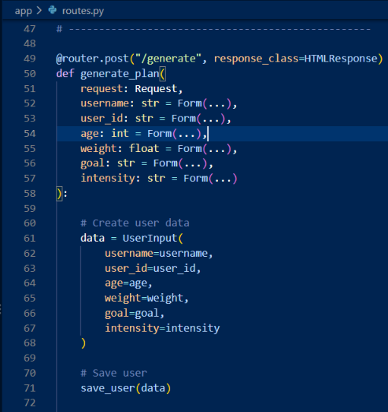
Figure 2: User input implementation
11.3 AI Fitness Plan Generation
The fitness plan generation module prepares a prompt using the user's information and sends it to the Gemini AI service. The generated response contains a seven-day general wellness and fitness plan.
Sample Coding:
plan = generate_fitness_plan(
username,
age,
weight,
goal,
intensity
)
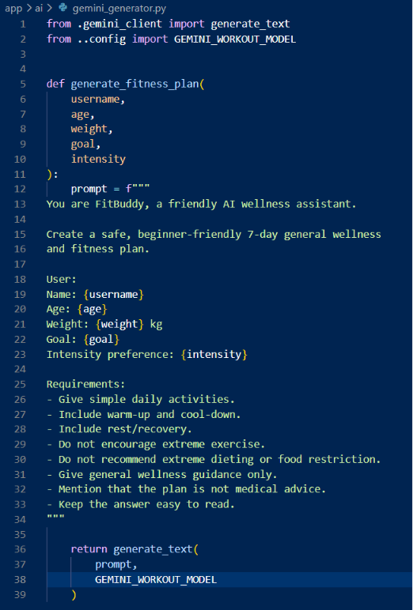
Figure 3: AI fitness plan generation
11.4 Gemini AI Integration
The Gemini client communicates with the Gemini AI service and receives the generated response. The response is returned to the application for displaying the required wellness information.
Sample Coding:
response = client.models.generate_content(
model=model,
contents=prompt
)

if response.text:
return response.text
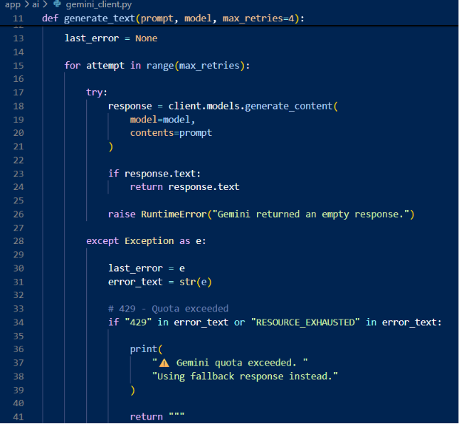
Figure 4: Gemini AI API integration

11.5 Nutrition Tip Generation
The nutrition module generates simple wellness and nutrition tips based on the user's fitness goal and intensity. The generated tips are displayed along with the fitness plan.
Sample Coding:
nutrition = generate_nutrition_tip(
goal,
intensity )
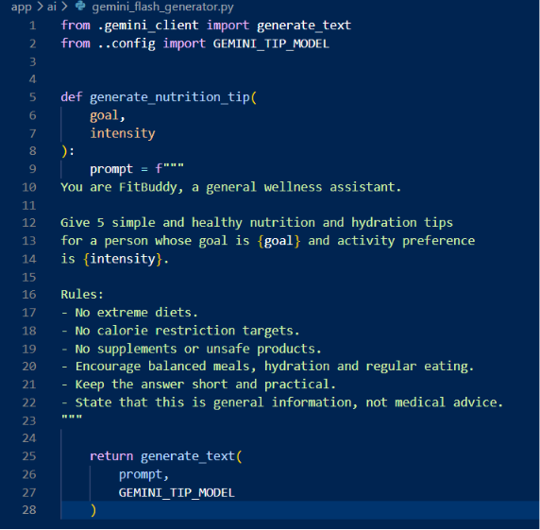
Figure 5: Nutrition tip generation
11.6 Feedback and Plan Update
The feedback module allows the user to provide feedback about the generated fitness plan. The application uses the feedback to create an updated plan and stores the updated information.
Sample Coding:
updated = update_fitness_plan(
plan.original_plan,
feedback
)

update_plan(
user_id=user_id,
updated_plan=updated,
feedback=feedback,
nutrition_tip=nutrition
)
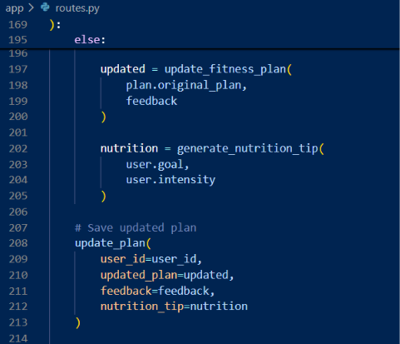
Figure 6: Fitness plan update using user feedback
11.7 Error Handling
The Gemini client handles temporary service errors, quota errors, and connection problems. If the AI service is unavailable, the application provides a fallback message instead of stopping the application.
Sample Coding:
except Exception as e:
error_text = str(e)

if "429" in error_text:
return "Gemini quota exceeded. Please try again later."
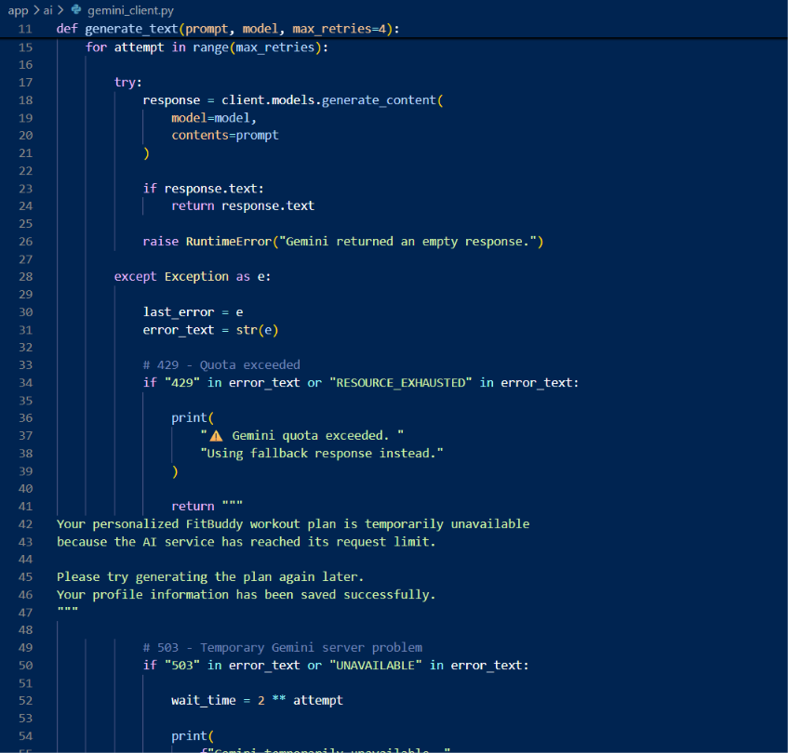
Figure 7: Error handling in Gemini API
11.8 Result Display
The generated fitness plan and nutrition tips are displayed on the result page using Jinja2 templates. The backend sends the generated information to result.html.
Sample Coding:
return templates.TemplateResponse(
request=request,
name="result.html",
context={
"request": request,
"plan": plan,
"nutrition": nutrition
}
)
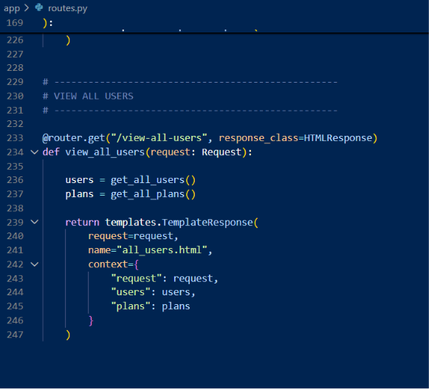
Figure 8: Result page implementation

12. USER INTERFACE AND OUTPUT SCREENS
The FitBuddy application provides a simple and user-friendly web interface. Users can enter their personal information, generate a fitness plan, view nutrition tips, provide feedback, and view the updated plan.
12.1 Home Page
The home page is the starting point of the FitBuddy application. It allows the user to enter details such as name, user ID, age, weight, fitness goal, and workout intensity.
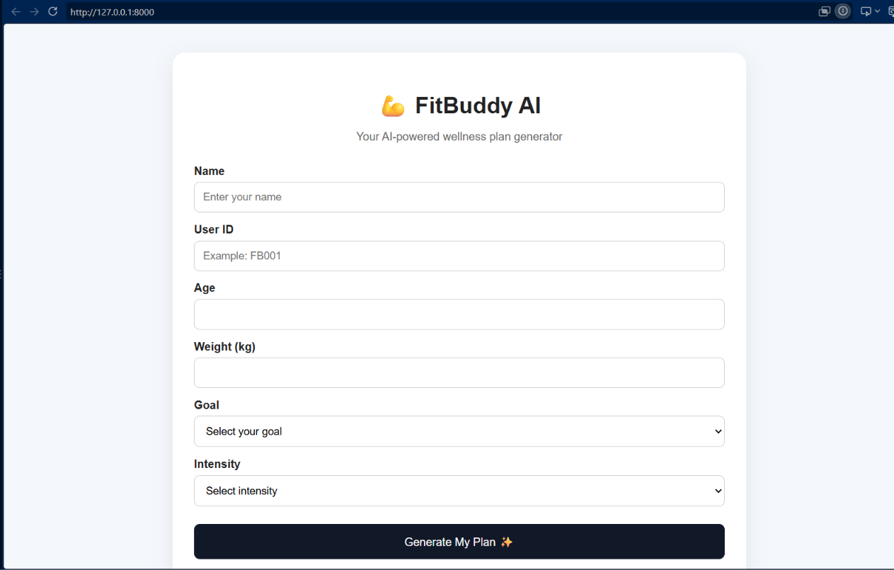
Figure 11: FitBuddy home page
12.2 Fitness Plan Output
After submitting the user information, the application generates a personalized seven-day general wellness and fitness plan. The plan is displayed on the result page.
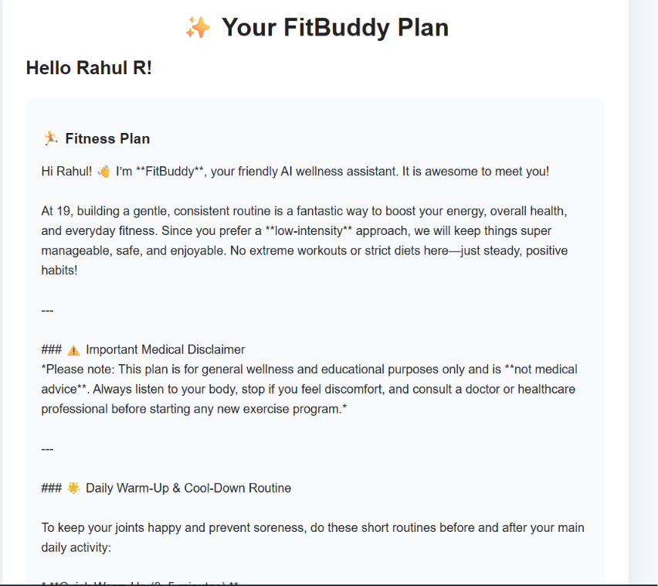
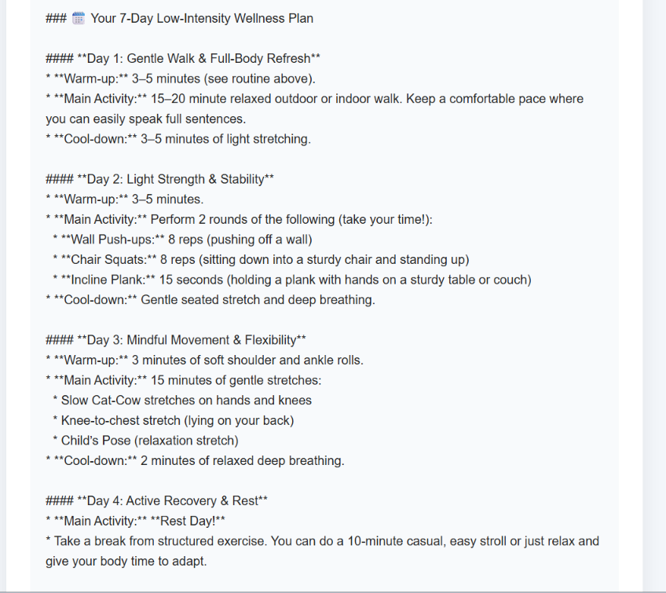
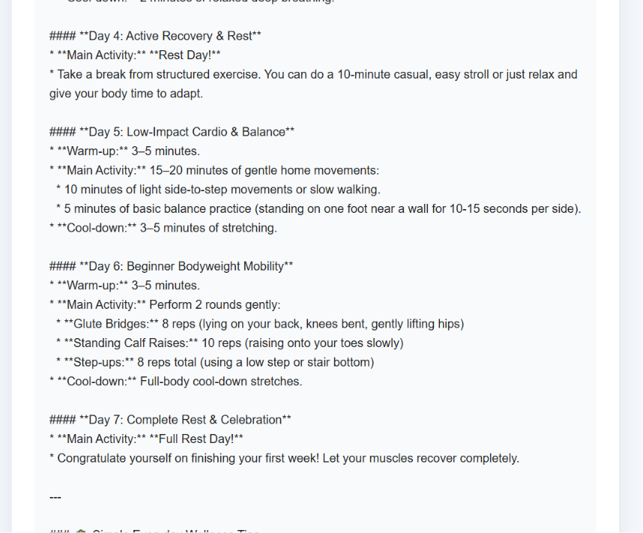
Figure 12: Generated seven-day fitness plan

12.3 Nutrition Tips
The result page also displays general wellness and nutrition tips based on the user's selected goal and intensity.
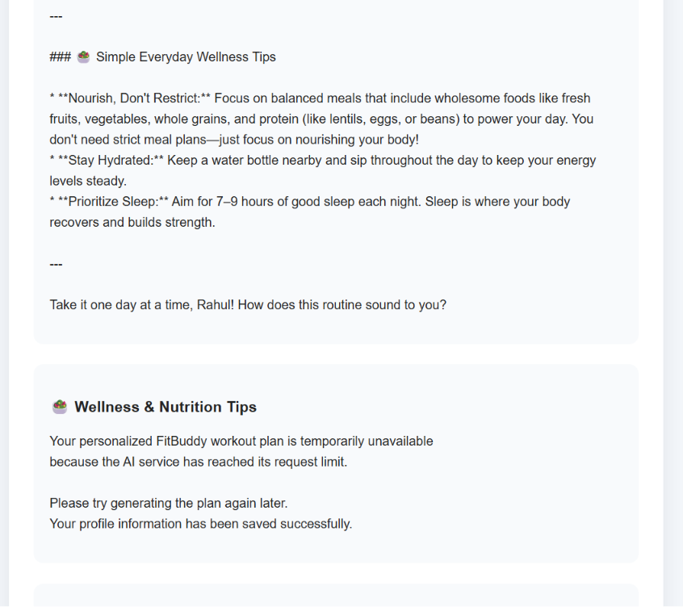
Figure 13: Generated nutrition and wellness tips
12.4 Updated Fitness Plan
The user can provide feedback about the generated plan. Based on the feedback, the application updates the plan and displays the revised result.
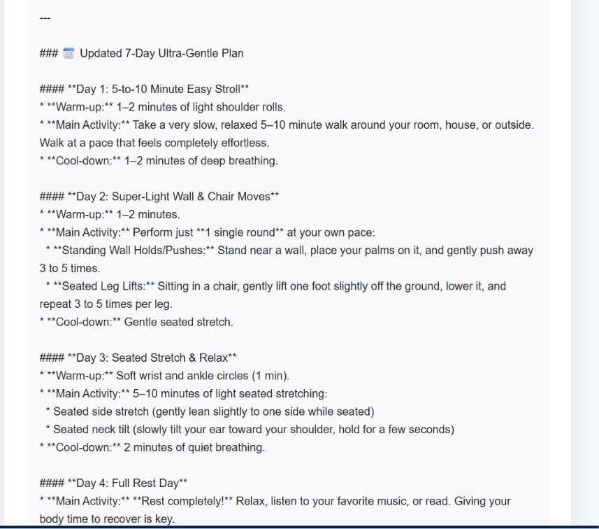
Figure 14: Updated fitness plan after user feedback
12.5 View All Users
The View All Users page displays the users and their stored plan information retrieved from the database.

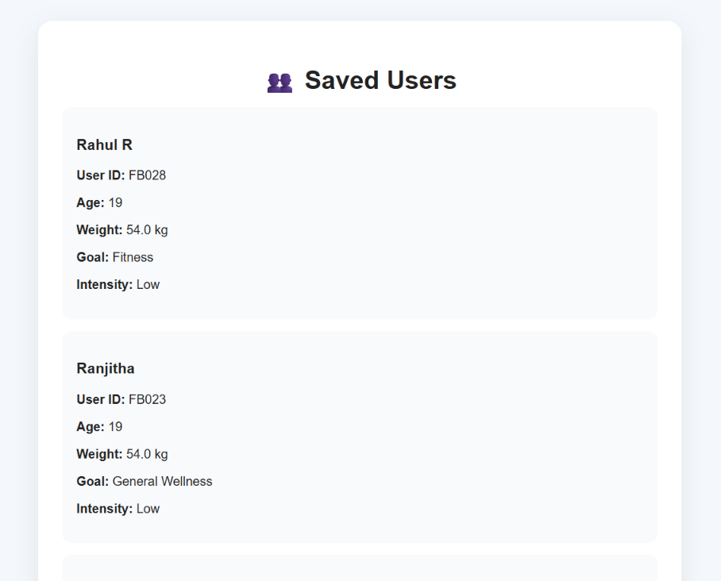
Figure 15: View all users and stored plans

13. TESTING
The FitBuddy application is tested to verify that all major features work correctly. Different test cases are performed for user input, fitness plan generation, nutrition tips, feedback-based plan updates, database operations, and error handling. The expected results are compared with the actual application output to ensure proper functionality.
13.1 Testing of User Input
The user input form is tested by entering valid details such as username, user ID, age, weight, fitness goal, and workout intensity. The system successfully receives and processes the submitted information.
Expected Result: User details should be accepted and stored successfully.
13.2 Testing of Fitness Plan Generation
The fitness plan generation feature is tested by submitting valid user information. The system processes the information and displays a seven-day general wellness and fitness plan.
Expected Result: A seven-day fitness plan should be displayed successfully.
13.3 Testing of Nutrition Tips
The nutrition feature is tested by providing different fitness goals and intensity preferences. The system generates general wellness and nutrition guidance.
Expected Result: Nutrition and wellness tips should be displayed along with the fitness plan.
The feedback functionality is tested by submitting feedback for an existing fitness plan. The system processes the feedback and generates an updated plan.
Expected Result: The updated fitness plan should be displayed successfully.
13.5 Testing of Database Operations
The database functionality is tested by checking whether user information and generated plans are stored and retrieved correctly.
Expected Result: User and plan information should be stored and displayed through the View All Users feature.
13.6 Testing of Error Handling
The application is tested when the Gemini AI service is temporarily unavailable or when the API request limit is reached. The system provides an appropriate fallback message.
Expected Result: The application should display a suitable error or fallback message without crashing.
13.7 Test Cases

Test case | Input/Action | Expected Result | Status
TC01 | Enter valid user details | User details accepted | Pass
TC02 | Generate fitness plan | Seven-day plan displayed | Pass
TC03 | Generate nutrition tips | Nutrition tips displayed | Pass
TC04 | Submit feedback | Updated plan displayed | Pass
TC05 | View stored users | User information displayed | Pass
TC06 | AI service unavailable | Fallback message displayed | Pass

14. RESULTS AND DISCUSSION
The FitBuddy application was successfully developed as an AI-based fitness and wellness plan generator. The system accepts user information and generates a seven-day general wellness and fitness plan based on the provided details.

14.1 Fitness Plan Generation Result
The application successfully generates a seven-day fitness plan using the user's age, weight, fitness goal, and selected workout intensity. The generated plan is displayed clearly on the result page.
14.2 Nutrition Tip Result
The application generates general nutrition and wellness tips based on the user's selected goal and intensity. These tips are displayed along with the fitness plan.
14.3 Feedback-Based Plan Update
The feedback feature allows users to provide feedback about the generated plan. The application processes the feedback and displays an updated fitness plan.
14.4 Database Result
The application successfully stores user information and generated plans in the SQLite database. The stored information can also be accessed through the View All Users page.
14.5 Error Handling Result
The application handles temporary AI service problems, quota limitations, and connection errors by displaying suitable fallback messages. This helps the application continue operating without unexpected termination.
14.6 Overall Result
The completed FitBuddy application provides a simple web-based platform for generating general fitness and wellness guidance. The integration of FastAPI, SQLite, Jinja2 templates, and Gemini AI provides the required functionality of the project.
14.7 Discussion
The results show that the FitBuddy application successfully connects the user interface, backend, database, and AI service into a single workflow. The application can accept user details, generate fitness and nutrition guidance, store the information, and update the plan based on user feedback. The testing results also show that the major functions of the application work as expected.

15. FUTURE ENHANCEMENTS
The FitBuddy application can be enhanced with additional features in the future to improve its functionality and user experience.
15.1 Mobile Application
The system can be developed as a mobile application so that users can access their fitness plans and wellness guidance easily from smartphones.
15.2 Progress Tracking
A progress tracking feature can be added to record the user's activities and show changes over time through simple charts or reports.
15.3 Exercise Demonstrations
The application can include exercise images or short instructional videos to help users understand the recommended activities correctly.
15.4 Reminder Notifications
Workout, water, and general wellness reminders can be added to help users maintain a regular routine.
15.5 Improved Personalization
Future versions can provide more personalized recommendations by considering additional user preferences and previous feedback.
15.6 Advanced Dashboard
An interactive dashboard can be added to display user plans, progress information, nutrition tips, and previous activities in one place.
16. CONCLUSION
The FitBuddy application was successfully developed as an AI-based fitness and wellness plan generation system. The application provides a simple and user-friendly interface for entering user details such as name, age, weight, fitness goal, and workout intensity.
The system uses FastAPI for backend processing, SQLite for storing user and plan information, Jinja2 templates for displaying the web pages, and Gemini AI for generating fitness plans and nutrition tips. The feedback feature allows users to provide feedback and receive an updated fitness plan.
The project successfully demonstrates the integration of artificial intelligence with a web application to provide general fitness and wellness guidance. The developed system achieves its main objective of generating personalized general wellness plans while maintaining user information and plan history.

REFERENCES
- Python Documentation
- FastAPI Documentation
- Google Gemini API Documentation
- SQLite Documentation
- Jinja2 Documentation

